📘 DBMS Cheat Sheet – Query Processing & Relational Algebra

🔹 Relational Algebra Operators

Projection (π)
- Keeps only selected attributes.
- πA1, A2,...,An(R) → relation with only these attributes.
- Duplicates eliminated (Relational Algebra).
- SQL default → duplicates not eliminated (need DISTINCT).

Selection (σ)
- Picks tuples satisfying condition C.
- σC(R) → same schema as R.
- C can be =, <, >, ≤, ≥.

Cartesian Product (×)
- R × S = all possible pairs.
- Schema = union of R and S.
- If common attributes → disambiguate using R.A, S.A.

Join (⋈)
- Natural Join = only tuples matching on common attributes.
- Schema = union of R and S, but common attributes appear once.
- Size formula:

(Containment assumption).

Set Operations
- Intersection (∩) → tuples in both.
- Union (∪) → tuples in either (duplicates eliminated).
- Difference (R-S) → tuples in R not in S.
- Require same schema.

🔹 Size Estimation Rules

Statistics
- T(R) = #tuples
- S(R) = tuple size (bytes)
- B(R) = #blocks
- V(R,A) = #distinct values of attribute A
- DOM(R,A) = domain size of A

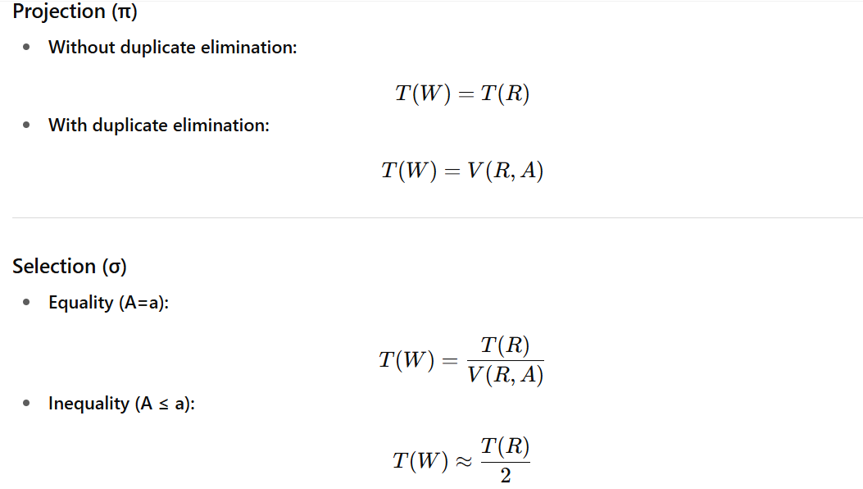
(uniform assumption, unless more info given).

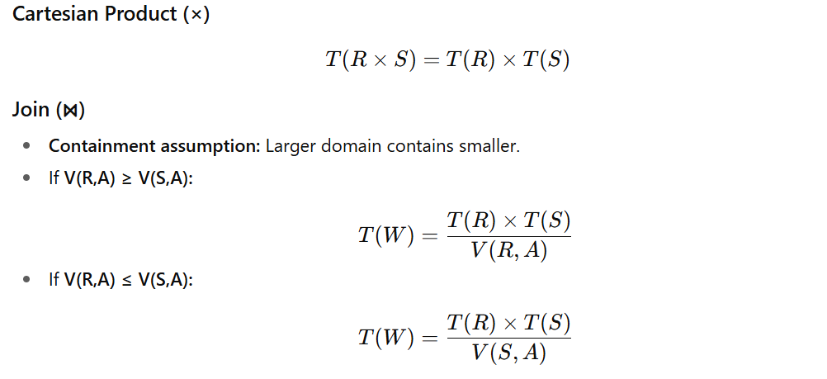

Preservation of Value Sets
- After selection: other attributes keep original distinct counts.
- After join:
  - For join attribute A:
  - Other attributes retain original V-values.

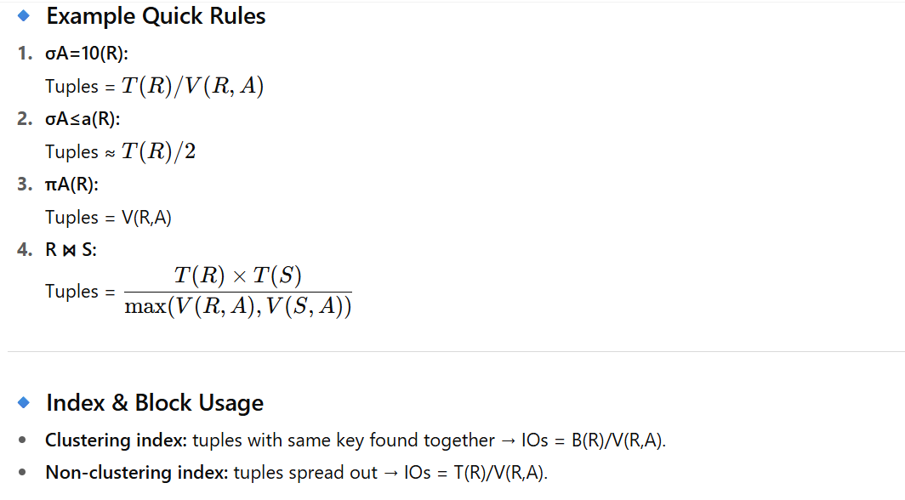

✅ This cheat sheet gives you:
- All relational algebra operators.
- Size estimation formulas (projection, selection, join).
- Quick examples & IO cost intuition.

